1. Find the domain of the function 

2. Suppose that the graph of $f$ is given. Describe how the graph

of the function $y=f\left(x+5\right)-6$ can be obtained from the graph of $f$.

A. Shift the graph 5 units to the right and 6 units down

B. Shift the graph 5 units to the left and 6 units down

C. Shift the graph 5 units to the left and 6 units up

D. Shift the graph 5 units to the right and 6 units up

3. Find

4. For what values of *c* is the function $f\left(x\right)=\left\{\begin{aligned}&3x+1,x>0 \\ &cx-3 ,x≤0\end{aligned}\right.$

continuous on ?

5. The graph of a fuction f is shown, find:  .

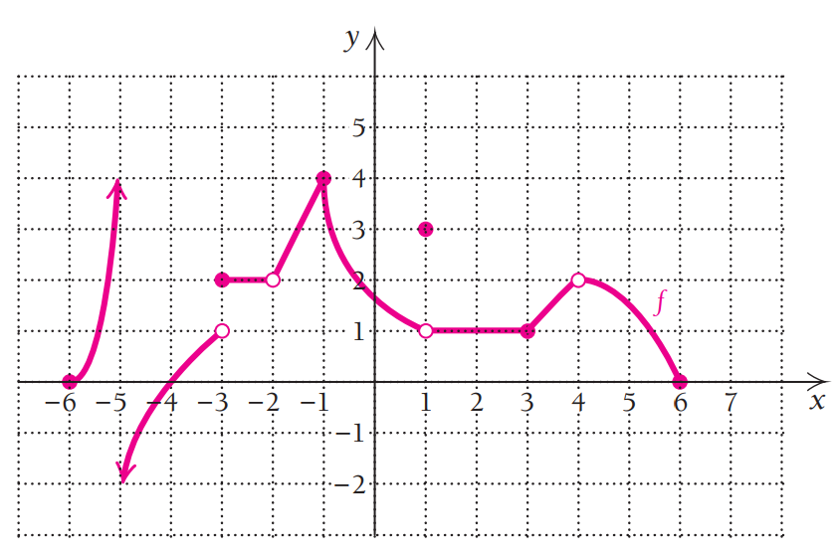

6.

State the numbers at which is not differentiable



7.

A table of values for f,g,f ',g' is given

|  |  |  |  |
| --- | --- | --- | --- |
| *x* | 0 | -1 | 2 |
| *f(x)* | 1 | -2 | -4 |
| *f '(x)* | 2 | -1 | 2 |
| *g(x)* | 1 | 2 | -1 |
| *g'(x)* | -2 | -1 | -2 |

Find h'(2) if h(x)=f(g(x))

8. For. Find $f'\left(3\right)$

9.

Find $\frac{dy}{dx}$ by implicit differentiation if

10. Find the linear approximation for $f\left(x\right)=\sqrt{2x+1}$ at $x=4$.